**Day four of Network Analysis**

1. 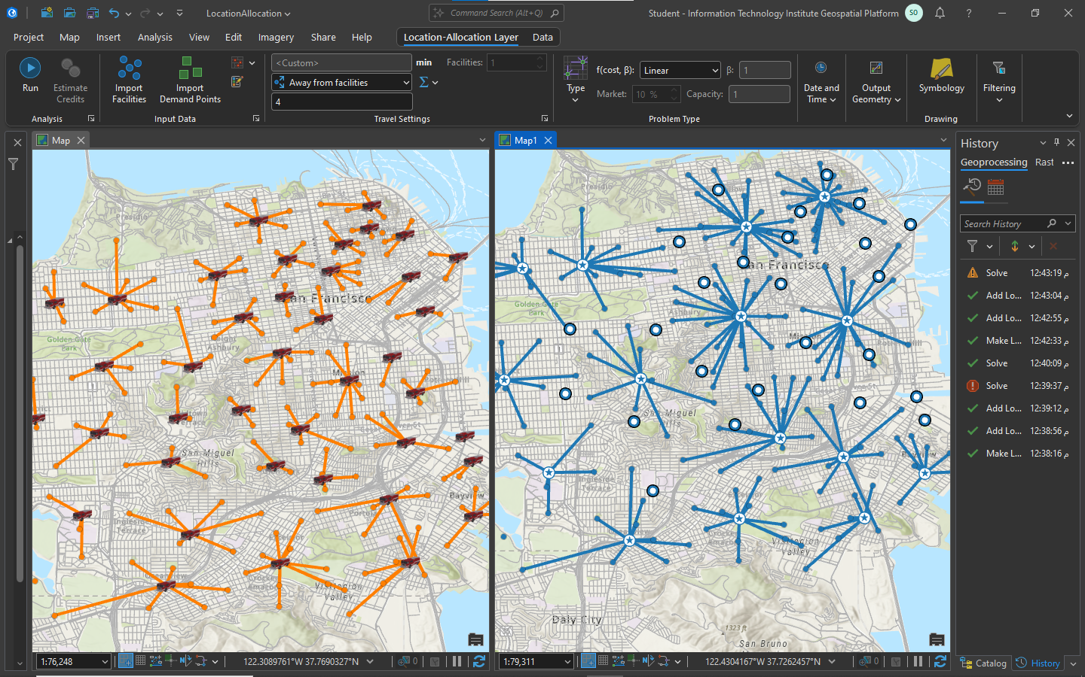**Maximize coverage vs Maximize coverage and minimize facilities**
2. 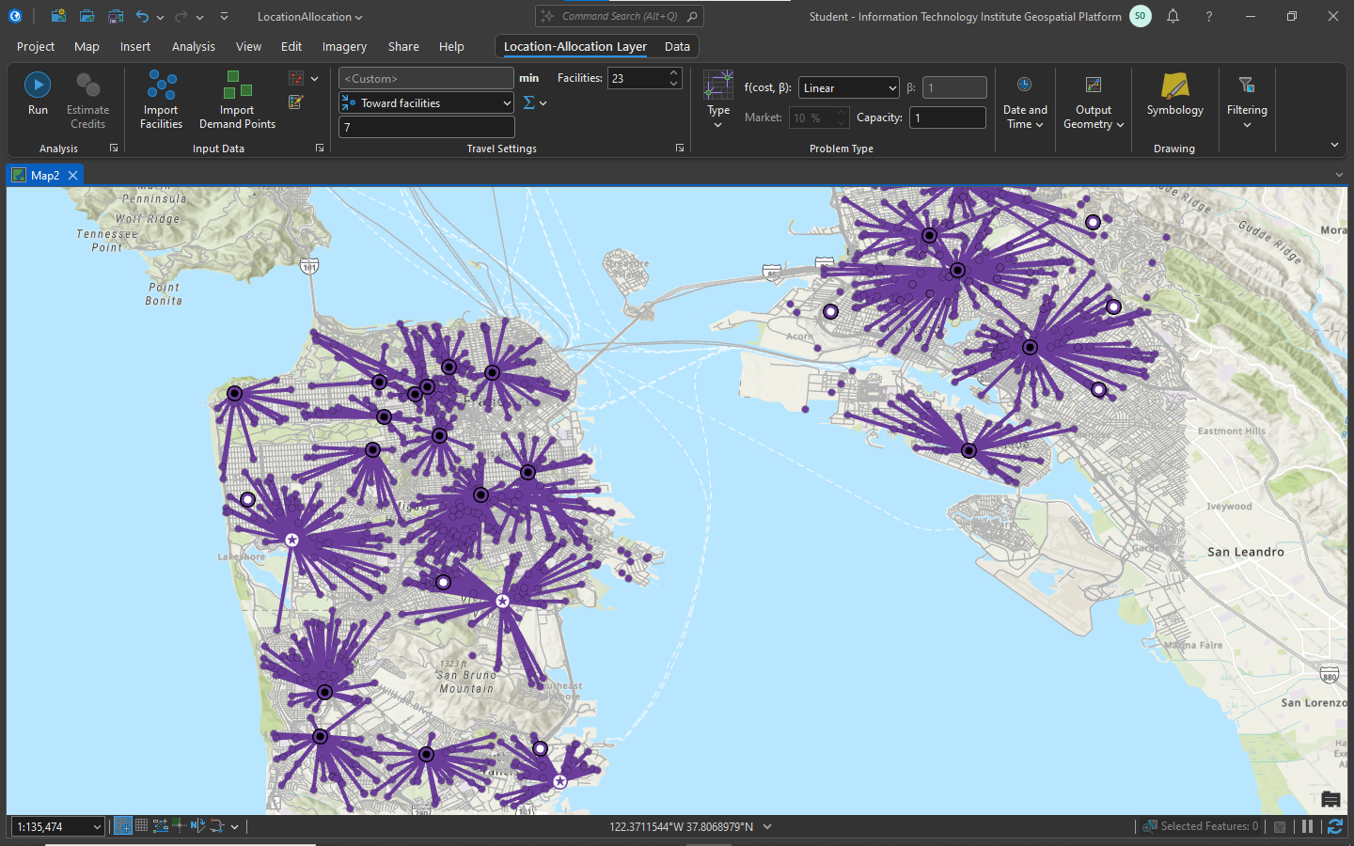**Maximize capacity coverage**
3. 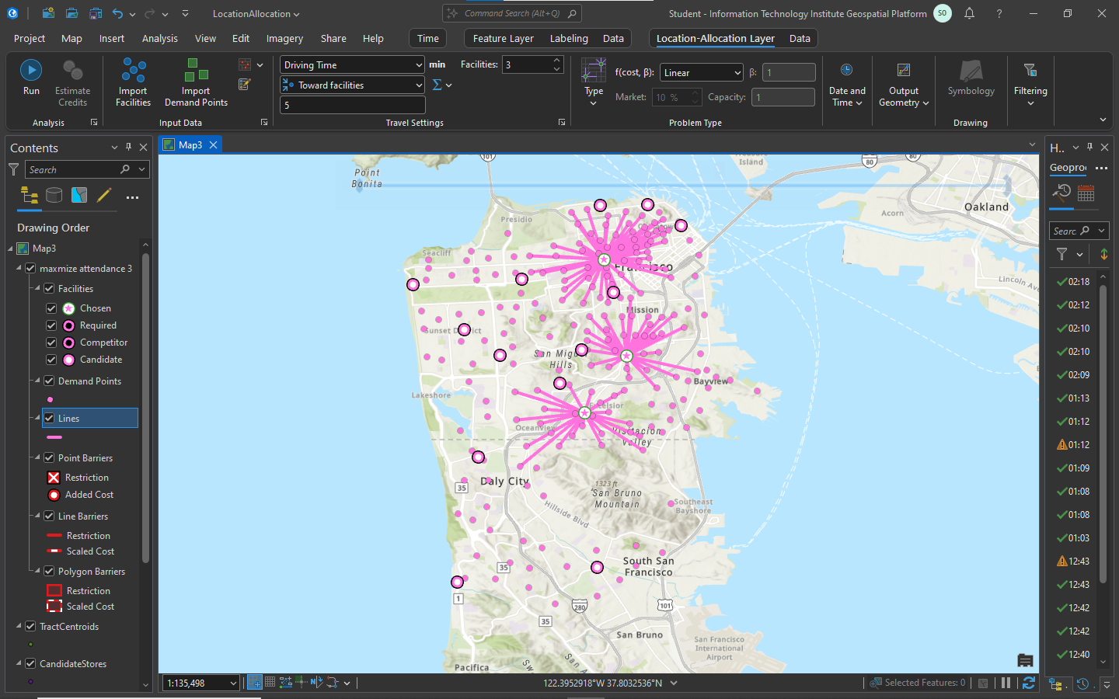**Maximize attendance only**
4. 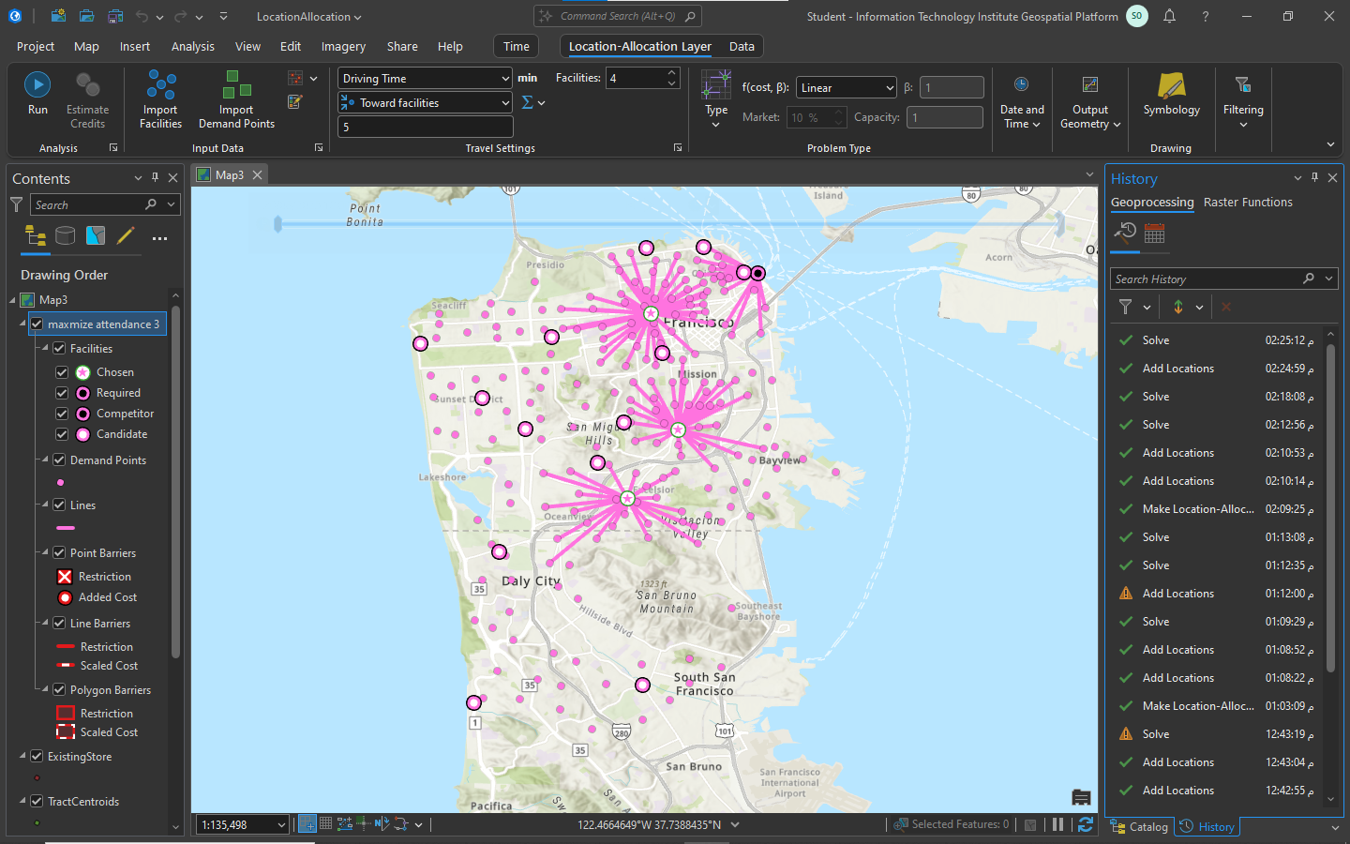**Maximize attendance and there is an existing stores as a required**
5. 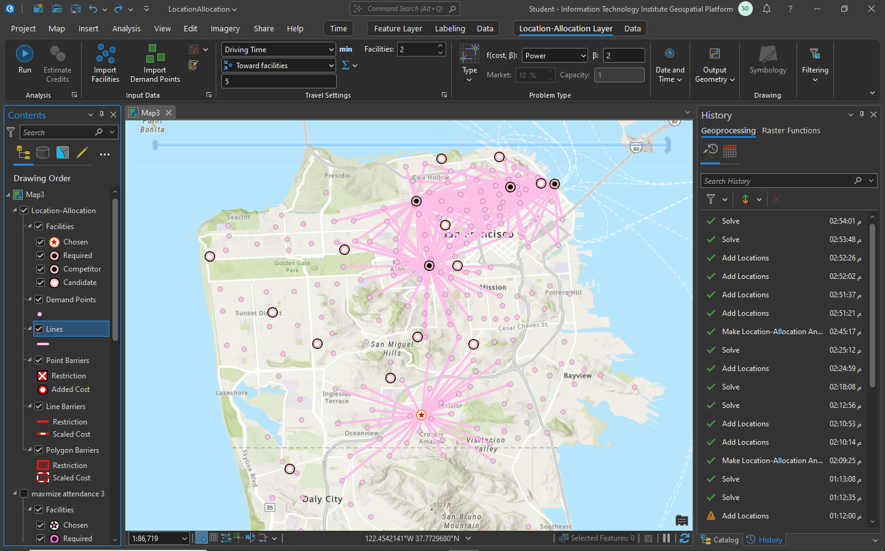**Maximize market share**